Materials Characterization Facility
(MCF)

Lab Manual

June 2021

Contents
1. MCF Access Protocol 2
1.1. Becoming an MCF user 2
1.2. Instrument training request 2
1.3. Card key access authorization 3
1.4. Personal protective equipment (PPE) 3
2. MCF operation hours 4
3. MCF visitor access guidelines 4
4. MCF safety 4
4.1. General safety rules 4
4.2. Chemical safety 5
4.3. General handling of laboratory chemicals 6
4.3.1. Handling solvents 6
4.3.2. Solution mixing guidelines 6
4.3.3. Handling hydrofluoric acid (HF) 6
4.3.4. Dispensing liquid nitrogen 7
4.3.5. Bringing new chemicals into the MCF 7
4.3.6. Electrical Safety (taken from OSHA’S quick facts) 8
4.3.7. Fire Fighting procedures for controllable fires 8
Appendix I. MCF Floor Map 10
Appendix II. Hydrofluoric acid (HF) Handling Guidelines 11
Appendix III. Chemical Description 14

All users are required to follow the MCF Rules and Precautions outlined in this document at all times. Failure to do so will result in suspension of access to the MCF.

1. MCF Access Protocol

1.1. Becoming an MCF user
To become an MCF user, all TAMU researchers are required to complete three of the laboratory safety courses provided by the Environmental Health and Safety (EHS) at TAMU before requesting to be trained on any of the MCF instruments. The laboratory safety trainings can be found at:
https://ehs.tamu.edu/how-do-i/register-for-laboratory-safety-training/

Student Training Resources
This includes undergraduate and graduate non-employee students. Students who do not have access to TrainTraq will need a temporary login password to access the trainings through TrainTraq External Gateway - Email labsafety@tamu.edu for a temporary password to access this training through TrainTraq External Gateway.
- Introduction to Laboratory Safety Training (Online) – Train Traq Course #2114106
OR
Introduction to Laboratory Safety Training (Classroom) – Train Traq Course #211126 – Students are not required to register online. Click here for training schedule.
- Hazard Communication Training (Online) – Train Traq Course #11020
- Working Safely with Cryogenics – Train Traq Course #211228

Note: The Introduction to Lab safety and Hazard communication courses must be renewed

every 2yrs.

1.2. Instrument training request
    - Create an iLab account by registering in our iLab - our online reservation and billing system.
To register for an iLab account:
- Click here to login and register.
- Click the blue Sign-Up button at the upper right corner.
- Click to register as a TAMU user, using your NET ID credentials
- Upon successful authentication, you will be prompted to select your PI/lab from the pull-down list and provide your phone number. Note: DO NOT select MCF as your lab.
- Submit the completed registration form. Submission will notify your PI of your lab membership request.
- Up on approval of your lab membership and account assignment by your PI, you will be sent an email with basic instructions on using the system at that time. Make sure your PI has approved your lab membership request and has assigned you an account. Otherwise you will not be able to make requests for training or use the MCF.
    - Submit a training request.
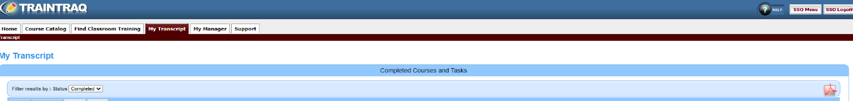
- Once you are assigned an account by your PI, go back to the iLab MCF Core webpage. Click on the “Request Services” tab. Click the initiate request box to fill out the “MCF NEW USER CONTRACT.” This is your confirmation that you have read the MCF Manual and your agreement to abide by all MCF lab safety rules. You will be asked to upload documentation that you have completed the lab safety courses through TAMU Environmental Health & Safety (either online or in a classroom). Upload either the course completion certificate or the pdf copy of your TrainTraq transcript (from SSO) showing that you have completed the lab safety courses.

- Next, on the “Request Services” tab of the MCF Core webpage, initiate a “Training Request” and complete the form for the instrument you wish to be trained on. You will be contacted by MCF staff once your request has been approved to schedule your training time. (Please, submit this simultaneously with the New User Contract.)
    - Make sure you are wearing lab appropriate clothing (no shorts, or skirts, or open toe shoes) and bring the appropriate eye protection (as discussed with the MCF staff scientist) and gloves to your training sessions and at all times while working at the MCF.
Appropriate lab attire and Eye protection must be worn in all MCF labs at all times.
    - When you come for your first training session, an MCF staff scientist will give you the Work Area Specific Safety Training orientation for the MCF.

1.3. Card access authorization
Upon finishing all safety courses, MCF specific safety training, and the training required to be a qualified user of the requested instrument(s), users will be given card key access to the MCF lab that has the instrument for which they are qualified.

1.4. Personal protective equipment (PPE)
All MCF users are required to bring their own safety glasses or safety goggles and gloves and wear them at all times when they are at the MCF. In addition, wet lab users who need to bring chemicals for their experiments or analyses will need to contact MCF staff to get permission. The user is required to bring the appropriate personal protective equipment (PPE) such as a lab coat, masks, chemical splash goggles, and acid gloves as required for that specific chemical.

2. MCF operation hours
- Normal Operating Hours: Monday – Friday, 8AM – 5PM.
- After hours and weekend operation: is available for qualified users with card access only. It is strongly recommended that users take all necessary precautions when using the MCF during these hours to minimize safety risks. It is prudent to have another person with you or notify someone of your whereabouts if you have to work at the MCF outside of its normal operating hours.

3. MCF visitor access guidelines
- Anyone who would like to visit the MCF can submit a request via e-mail to the MCF Director or Facility Manager to schedule a tour.
- TAMU Principle Investigators (“PIs”) who wish to include an MCF tour/visit in their course work can submit a request via e-mail to the MCF Director or Facility Manager to schedule the tour/visit.

4. MCF safety
Safety is extremely important when conducting experiments. All MCF users are required to practice safe lab practices that they have learned from the MCF mandatory laboratory safety training described in sec. 1.1. In addition, all users are expected to practice the safety guidelines put in place by the MCF in this document. Any blatant disregard of safety guidelines will result in immediate expulsion from the MCF. The following safety guidelines apply to all labs at the MCF and MUST be observed at all times. When working in the lab, think of being S.A.F.E. – Smart, Alert, Focused, and Educated at all times.

4.1. General safety rules
- No eating or drinking is allowed in the lab.
- No open-toed shoes, sandals, or shorts may be worn in the lab.
- Long hair must be properly restrained.
- Proper attire in the lab includes nitrile or latex gloves (as needed), and safety glasses at all times when you are in the lab.
- Do not wear laboratory gloves outside the lab. Do not touch lab doors with lab gloves.
- Do not touch a computer keyboard or mouse with lab gloves.
- This is a shared user space. Keep your work area neat and orderly upon finishing your experiment.
- If there is a fire, activate fire alarm and leave the building immediately via the fire exits.

4.2. Chemical safety
- When in doubt of the proper procedure, never guess. Think S.A.F.E and always ask the MCF staff for help.
- When planning to work with chemicals, anticipate possible accidents and prepare yourself how to deal with problems that may occur.
- Know the locations of telephones within the lab (dial 911 in case of an emergency).
- Know the locations of emergency showers, eyewash stations, fire extinguishers, first aid kits, spill kits, and material safety data sheet (MSDS) (See Appendix I – map of MCF labs with eye wash, emergency shower, MSDS folder; and location of fire extinguishers).
- Always notify the MCF staff of any chemical spills or accidents after carrying out the required emergency treatment.
- If an acid or base splashes into a person's eye, flush the eye profusely with cold water for 15 to 20 minutes. It is imperative that the eye be held open during the rinse. After rinsing, notify the MCF staff and seek immediate medical treatment.
- If an acid or base splashes onto a person’s skin, rinse immediately in cold water for 15 to 20 minutes.
- If acid or base spills on a person’s clothing activate the emergency shower and rinse immediately, remove clothing while under the shower.
- For hydrofluoric acid (HF) burns, flush affected area with water for at least 15min and apply calcium gluconate gel immediately (See 4.3.3 and Appendix II for HF handling procedure). Note that HF is an inorganic acid that is highly corrosive and readily penetrates the skin, causing deep tissue layer destruction including bone before you feel anything on your skin. Pain associated with exposure to solutions of HF (1-50%) may be delayed for 1-24 hours.
- Solid spills can be brushed into a dust pan and disposed of in an appropriately labelled solid waste container. If necessary, slightly moisten the solid, to minimize dust production. Use water, or if the material is water reactive, another inert liquid (e.g. ethylene glycol). Always wear safety goggles and gloves when cleaning up a chemical spill.
- For liquid spills, dike around the spill using appropriate spill absorbent (located in the wet lab, Rm. 123). This will prevent the spill from spreading further. Do not use paper towel to absorb the spill since this increases the rate of evaporation and vapor concentration of the liquid. Carefully cover the spill area with spill absorbent starting at the outside and working inward. Dispose of the contaminated absorbent, PPE and gloves used to clean the spill in a black trash bag that can be found in the wet lab (Rm. 123). The trash bag should be sealed with a zip tie. Store for disposal as hazardous waste and notify MCF staff. Always wear splash goggles and gloves when cleaning up a chemical spill.

4.3. General handling of laboratory chemicals
A number of strong acids, solvents, and bases may be used in the wet lab. Users should be aware of the characteristics of each chemical used in the laboratory as well as the general handling guidelines and PPE required listed below. For more detailed information on the chemicals and materials used, see the MSDS folder located in the wet lab shelf by the sink. The MSDS of all the chemicals that are in the MCF are also available through the MCF website (http://mcf.tamu.edu/msds).

4.3.1. Handling solvents
- Solvents are volatile, and their fumes are highly flammable. Obviously, open flames are not allowed in the lab. If fumes from solvent in a beaker or flask should happen to ignite, snuff it by placing a watch glass over the container opening. Notify the MCF staff of any fire.
- If you are using organic solvents such acetone, isopropanol, and ethanol to clean your samples, never pour it into the sink. It should be poured into the designated waste container found in the lab.

4.3.2. Solution mixing guidelines
- Use a face shield rather than goggles. Mix chemicals inside a fume hood. Never look into the top of a beaker - always view it from the side.
- Pour chemicals slowly and make sure you have the right chemicals.
- Never pour excess chemicals back into the original containers. Pour excess chemicals into the appropriate waste containers. When finished, return containers to their storage locations immediately.
- Use caution when diluting acids or bases. Always dilute an acid or base by pouring it into water rather than pouring water into the acid or base solution, which can cause violent exothermic reactions.

4.3.3. Handling hydrofluoric acid (HF)
Hydrofluoric acid cannot be used without requesting written permission from the MCF staff and notifying a staff member before usage each time so that safety can be monitored before, during and after usage. It may ONLY be used in the MCF web lab (Rm. 123). Hydrofluoric acid can produce severe skin deep tissue burns, as well as bone injuries that are slow in healing. It is extremely dangerous because burns may not be noticed until sometime after the exposure and the burns can be extremely painful. HF burns require immediate medical attention. Please see Appendix II for additional general handling information. Contact TAMU’s Environmental Health and Safety (EHS) for HF specific trainings and safe lab practices.

4.3.4. Dispensing liquid nitrogen
If you need to use liquid nitrogen, a large, low-pressure cylinder is located in the MCF wet lab (Rm. 123). Use the cryogenic blue gloves and the safety glasses or face shield provided when dispensing liquid nitrogen into a Dewar and when working with liquid nitrogen at all times.

4.3.5. Bringing new chemicals into the MCF
If you would like to bring any chemical(s) for use in the MCF wet lab, you must contact the MCF staff in charge of the wet lab to prepare a protocol for your chemical usage while at the MCF and receive training and approval. Once your request is approved please contact TAMU’s Environmental Health and Safety (EHS: https://ehsd.tamu.edu/Pages/Home.aspx) for proper procedures for transporting it to the MCF. In addition, adhere to the following safety precautions:

Safety Precautions
- Make sure your PI sets up MCF as your alternative pick up lab in the Dakota system so that you can make arrangements for your waste to picked up. Label your chemical container. (You can download the chemical label from our website: https://mcf.tamu.edu/forms/. You can refer to Appendix III as a quick reference for chemical description used for hazardous material classification.)
- Use the green TAMU hazardous waste tag Label to tag your waste container for your chemical.
- Make sure the fume hood is working properly before using it.
- Must Always wear chemical splash goggles (not safety glasses or spectacles).
- Always wear appropriate protective clothing, including gloves.
- Always check gloves for tears or punctures before using them. Never touch your face or body while wearing gloves and always rinse gloves off before removing them.
- Always start with clean beakers that have been placed top down in the drying rack.
- Always label beakers and do not let beakers of unused chemicals accumulate.
- Acids, bases and strong solvents should always be used in an exhausted fume hood located in the wet lab (Rm. 123).
- Rinse empty beakers thoroughly by placing them under a running water faucet for several minutes and then placing them top down in the drying rack.
- Never pour excess chemicals back into the containers. Pour excess chemicals into your labelled designated waste container. When finished, return containers to their storage locations immediately.
- When you are done working with your chemical or if your waste disposal container is full, make arrangement with EHS for pick up through Dakota system.
- Always assume unknown liquid spills are dangerous and treat them accordingly. Notify the MCF staff immediately.
- When in doubt about the proper procedure, never guess. Remember S.A.F.E. and always ask the MCF staff for help.

4.3.6. Electrical Safety (taken from OSHA’S quick facts)
One can be exposed to electrical hazards due to faulty electrical equipment/instrumentation or wiring, damaged receptacles and connectors, or unsafe work practices.
- Report any electrical failure or overheating of instruments to the MCF staff. Do not attempt to repair or maintain any electric circuitry or electronic equipment.
- Always follow manufacturer’s recommendations for using electrical equipment.
- Do not use electrical equipment to perform a task for which it is not designed.
- Most equipment includes either a 3-pronged plug or double insulation. Equipment with neither of these features is less safe but may meet electrical codes. You will not be protected from electric shock if a 3-pronged plug is not inserted into a 3-prong outlet.
- If you plug more than two pieces of low demand equipment into a standard outlet, use a fused power strip that will shut off if too much power is used.
- Do not disable any electrical safety features.
- Before turning equipment on, check that all power cords are in good condition.
- Do not use extension cords as a substitute for permanent wiring.
- If you see a person being electrocuted, DO NOT TOUCH HIM/HER! The electricity can go through you, too. If possible, turn off the power (pull the plug or trip the circuit breaker), or use an item made of non-conductive material (e.g., wooden broom handle) to pry him/her or her away from the contact. Then call 911 immediately and notify MCF staff.

4.3.7. Fire Fighting procedures for controllable fires
The decision of whether one should fight the fire oneself or wait for fire-fighting help must be made according to the type and size of the fire, its location and the circumstances of the fire.
- A small fire in a container may be easily snuffed out by the placement of a nonflammable cover across the container opening.
- A small fire in an area free of other fuels can be extinguished with appropriate available extinguishers before calling for help. When extinguishing a burning solid, direct the extinguisher discharge at the base of the flame; in the case of burning liquids, direct it at the leading edge. To extinguish a minor fire with an extinguisher: Remember!
PASS: Pull Pin
Aim
Squeeze handle
Sweep from side to side
- Larger or rapidly growing fires are best left to the Fire Department; activate the fire alarm and leave the building immediately.

Appendix I. MCF Floor Map
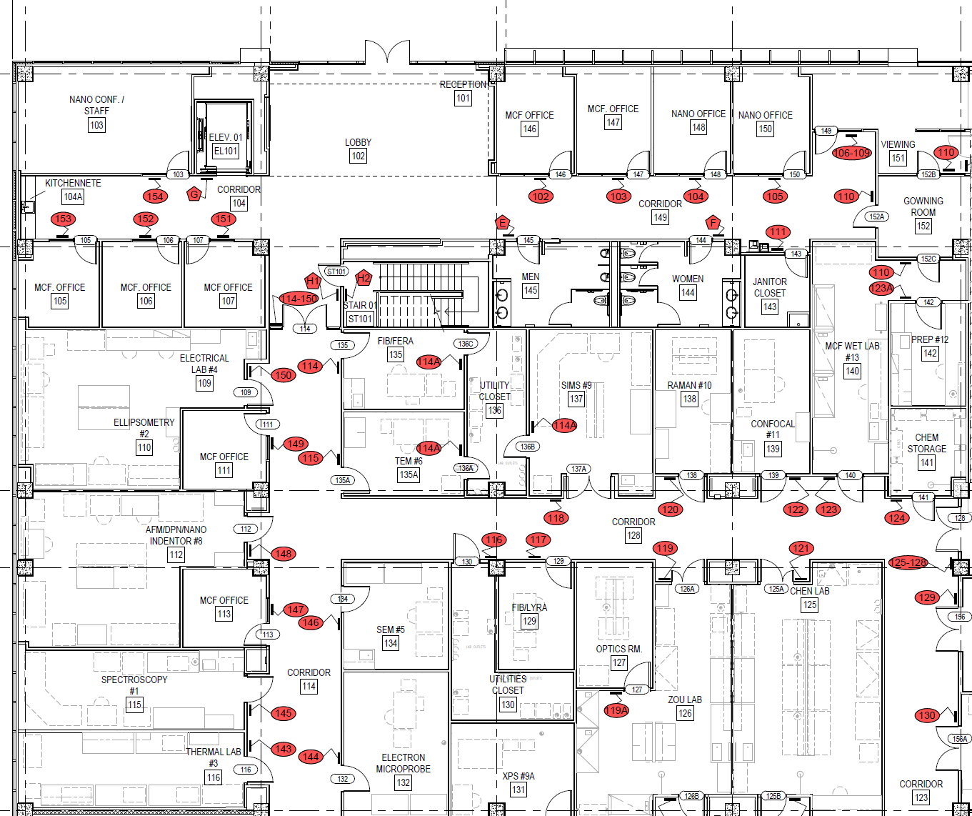
Fire Extinguisher
Eye Wash
Safety Shower
MSDS Folder
RAMAN
MCF
Wet
Lab
MCF
Prep
Lab
Confocal
Microprobe
Thermal
Spectroscopy
SEM
ComputerRoom
XPS
AFM/Nanoindenter/
Titan 300 Themis3 S/TEM
FIB-LYRA
FIB- FERA
AFM-IR

SIMS
SIMS

Appendix II. Hydrofluoric acid (HF) Handling Guidelines
HF will penetrate the skin and attack underlying tissues. HF may produce severe ocular and dermal injury as well as acute life threatening systemic toxicity with minimal external tissue damage. Both liquid and vapor can cause severe burns, which may not be immediately painful or visible.

Proper Protective Equipment (PPE)
The handling of HF solution requires special protective equipment:
- A full face shield in conjunction with goggles.
- Heavy duty neoprene rubber gloves (standard nitrile gloves will not provide sufficient protection).
- An acid resistant apron to wear on top of the lab coat.

Proper HF Solution Handling
- All users must thoroughly read and understood the attached Hydrogen Fluoride Emergency Protocol.
- Personal protective gear is imperative as noted above.
- Check the availability of calcium gluconate (2.5%) before beginning any experiment and ensure it has not passed its expiration date. Do not attempt an experiment if calcium gluconate cannot be found.
- Check if HF spill kit is available before attempting an experiment.
- HF is a glass etchant; only use plastic lab ware to contain HF, not glass beakers. Use chemically
compatible containers, such as those made from polyethylene or Teflon.
- Check if the fume hood is working properly. HF should always be handled inside of a fume hood that is identified with a sign stating “Danger, Hydrofluoric Acid Used in this Area.”
- Know where the closet eyewash and emergency shower are located in the wet lab. Ensure your associability is not hindered before you begin your experiment.
- Always work with a chemically compatible secondary containment tray.
- Ensure HF containing vials and flasks are securely supported and not likely to tip over.
- Keep containers closed to minimize exposure and prevent etching of fume hood glass from
HF vapors.

Waste Disposal Procedures
- Waste HF must be placed in a compatible container (not glass) and labeled with the hazardous waste tags properly filled out.
- Once the waste container becomes full talk to MCF staff for proper disposal. HF must be transported in a specific way.

Accident / Injury Response
- Apply first aid as required.
- Notify MCF staff immediately.
- In the case of skin contact first aid must be started within seconds. If the skin contact is local, immediately remove any contaminated clothing and wash the area with water for 15 minutes. Apply generous amounts of calcium gluconate gel to the area. Gently massage the gel into the contaminated areas while using gloves. White specks appearing around the burned region indicates the formation of calcium flouride and that the gel is working. Gently apply the gel for 15 minutes and reapply when the pain flares up.
- If larger amounts of HF are spilled, or if HF is spilled in a difficult area to wash, remove clothing and proceed immediately to the nearest safety shower. After showering, put on a new pair of chemical resistant gloves (to prevent possible secondary HF burns) and massage calcium gluconate gel freely into the affected site. Apply the gel as soon as the washing is done. The affected area does not need to be dried first. The gel will turn white upon reaction with the acid. It is important to realize that calcium gluconate gel WILL NOT adequately neutralize the effect of HF on tissue by itself. Rinsing with water prior to application of the gel is critical.
- In case of eye contact, rinse the eyes with large amounts of water for a minimum of 5 minutes and seek medical attention. Do not apply calcium gluconate gel to the eyes. If sterile 1% calcium gluconate solution is available, start using it within the first 5 minutes (via continuous drip into eyes), and continue using it as the preferred flushing agent (Do NOT use 2.5% calcium gluconate GEL on the eyes). If sterile 1% calcium gluconate solution is not available, wash with copious amounts of water for 15minutes while holding eyelids apart.
- If HF is ingested, seek medical help immediately. Do not induce vomiting. If conscious, have the injured person ingest a glass of milk. If vomiting occurs naturally, help the person so they do not choke on the vomit.
- If HF vapor is inhaled, move the person to fresh air and seek medical attention at once.

Spills
- HF spill kit is located in the chemical storage area in Rm. 123.
- If HF is spilled outside a chemical fume hood, evacuate the area, close the doors, alert everyone nearby to prevent others from entering, and notify MCF staff immediately.
- Small spills inside a fume hood can be cleaned by lab staff if they have had proper training on HF
clean up and waste disposal.
Note: Spill kits that contain Floor-dri, kitty litter, or sand should NOT be used because HF reacts with silica to produce a toxic gas.

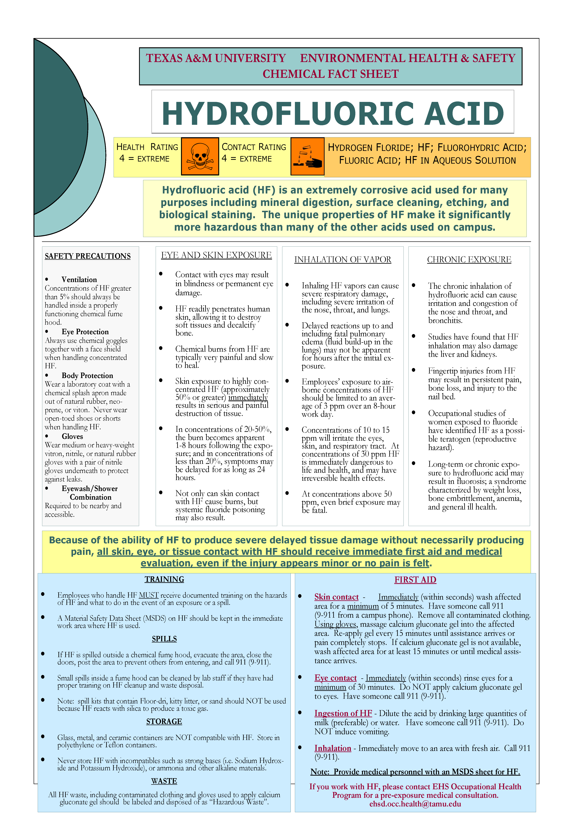

Appendix III. Chemical Description
This chemical description from the National Fire Protections Association is for your reference to help you correctly label your chemical if you wish to bring a chemical to the MCF. The National Institute for Occupational Safety and Health (NIOSH) is good source of information about chemical hazards of many chemicals. Refer to their NIOSH Pocket Guide to Chemical Hazards for the latest information on chemical toxicity; exposure limits (RELs) and those with permissible exposure limits (PELs), and more at http://www.cdc.gov/niosh/npg/search.html
Below is the National Fire Protection Association (NFPA) 704 Marking System for your reference.
